NAME-TUSHAR KUMAR SINGH

REG NO-22BCE1975

TITLE-BLOG WEBSITE USING [NODE.JS](http://node.js) and MONGO DB

SCREENSHOTS:

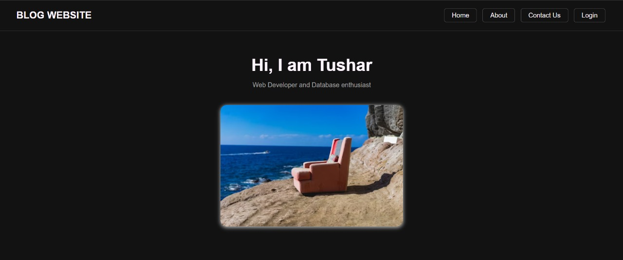

Fig 1: Home Page

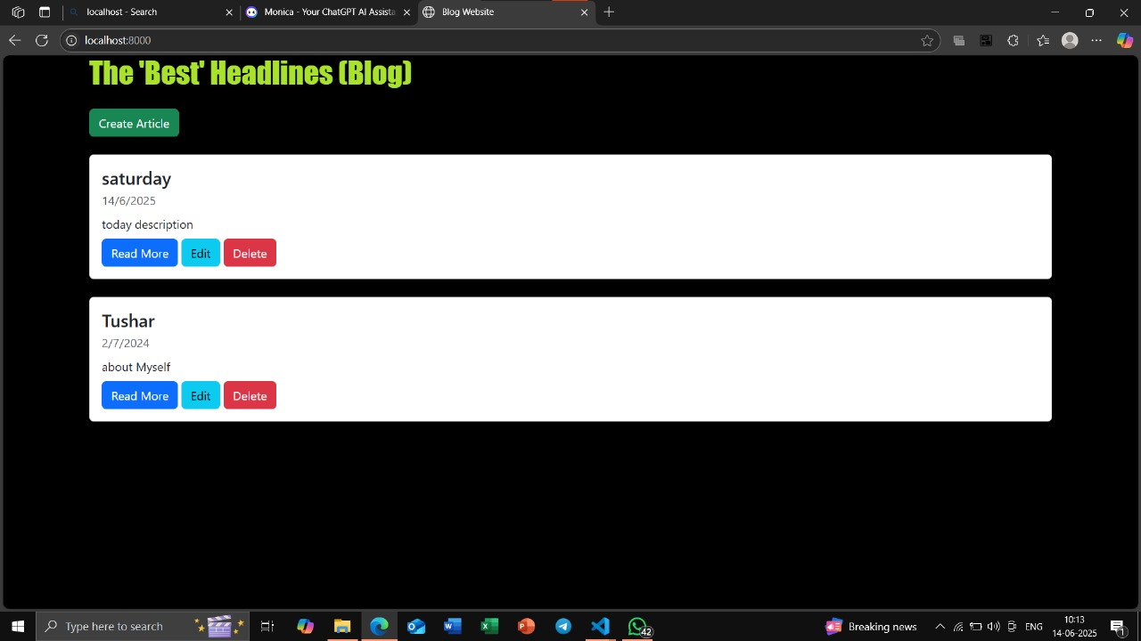Fig 2: Click on create article add a article. To view the stored article you can click on read more, to edit the article you can choose edit and to delete any article you can choose delete.

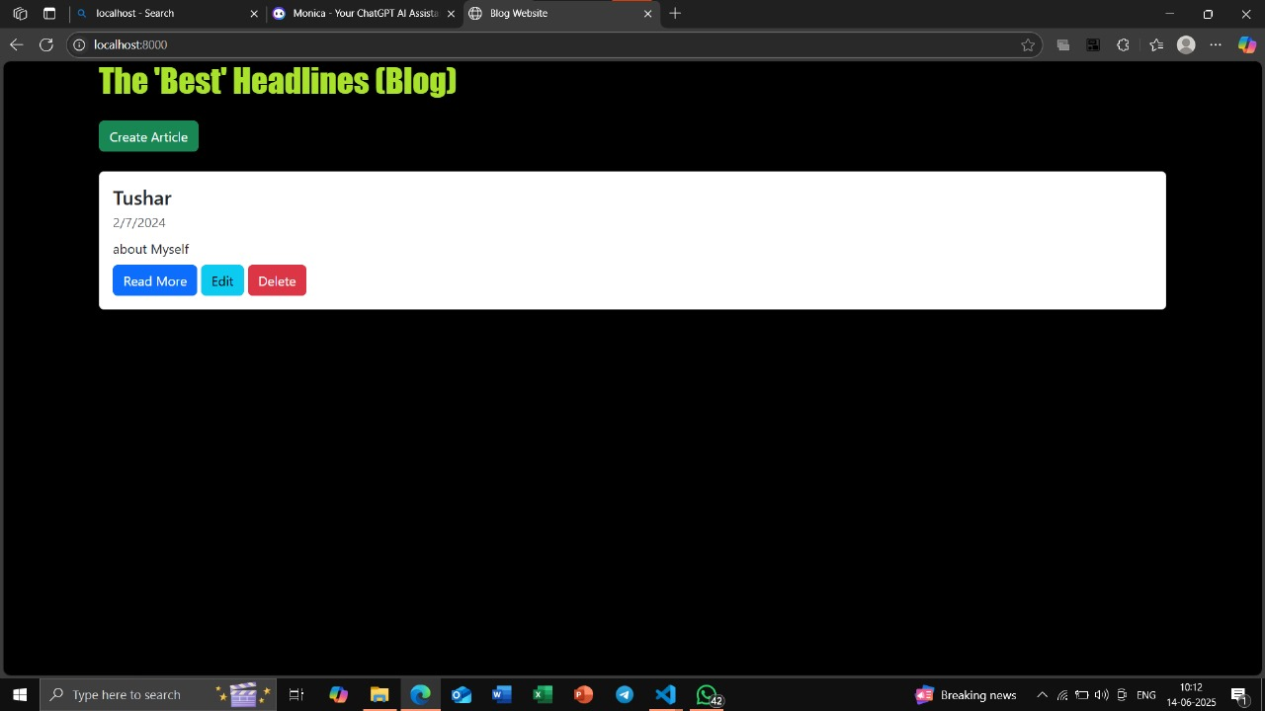

Fig 3: Click on Delete icon to delete that article

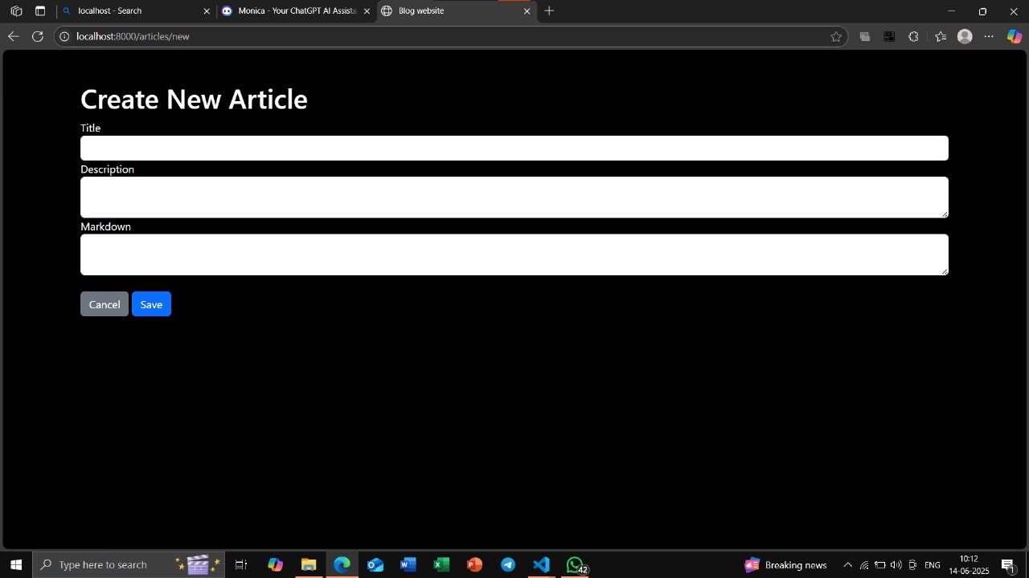

Fig 4: Add title description and markdown for our article and click on save button.

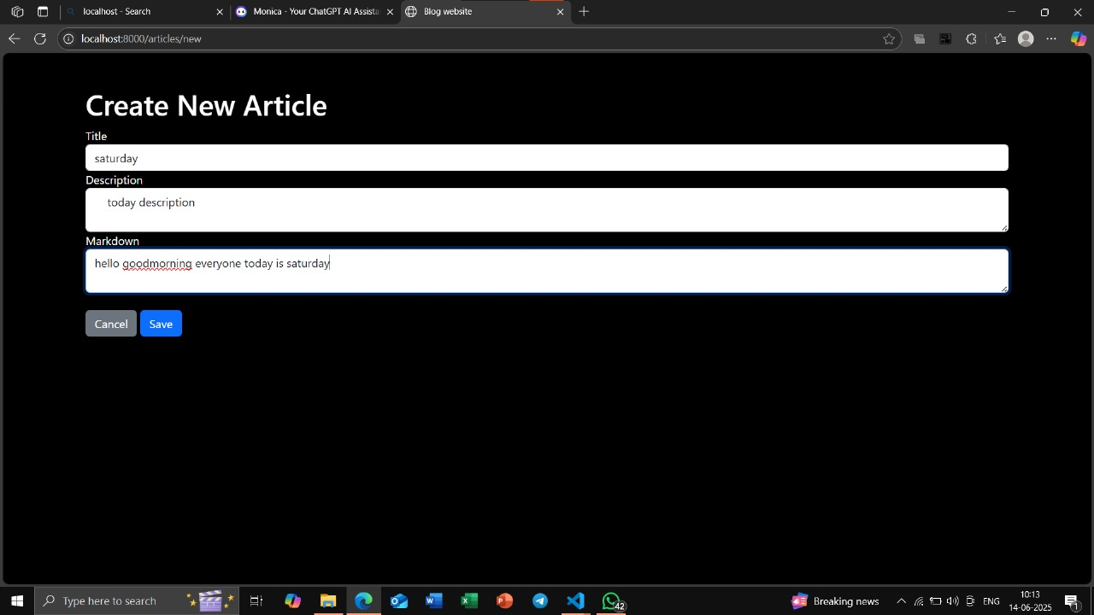

Fig 5: After adding all things in this Create New Article

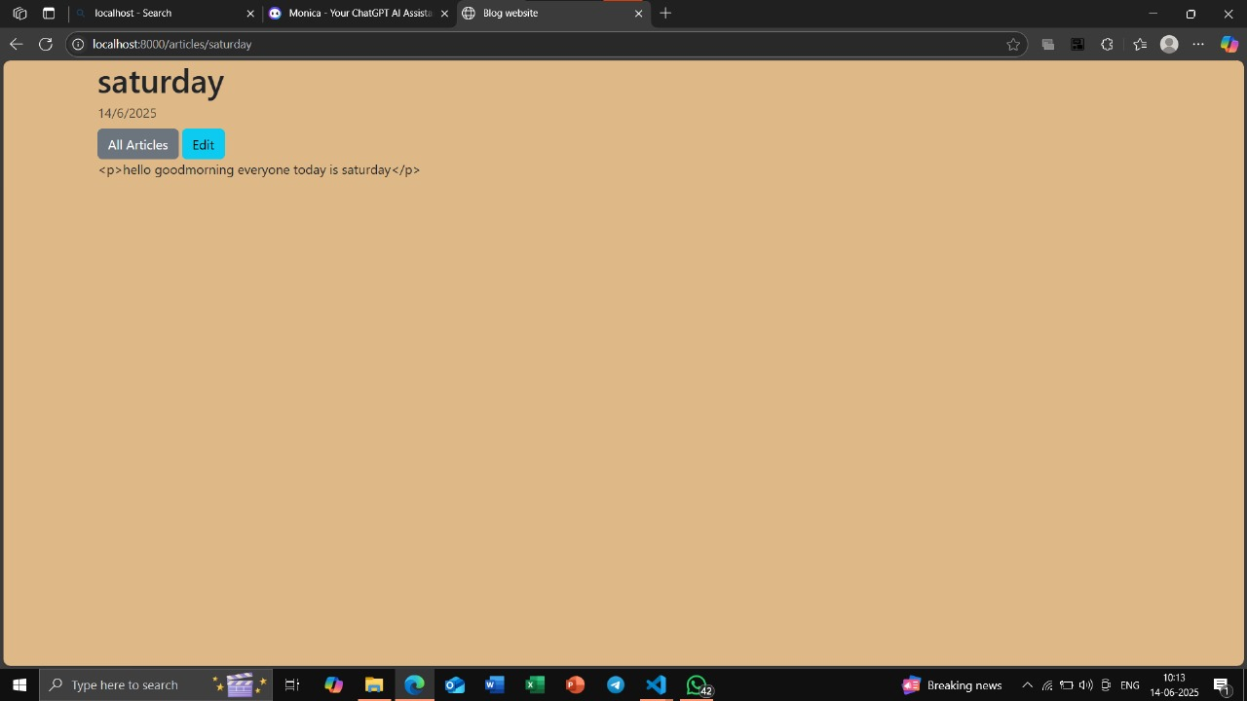

Fig 6: We can edit our article once its saved and to view all the article click on all article.



Fig 7: We can see that the article saturday has been added in the list.